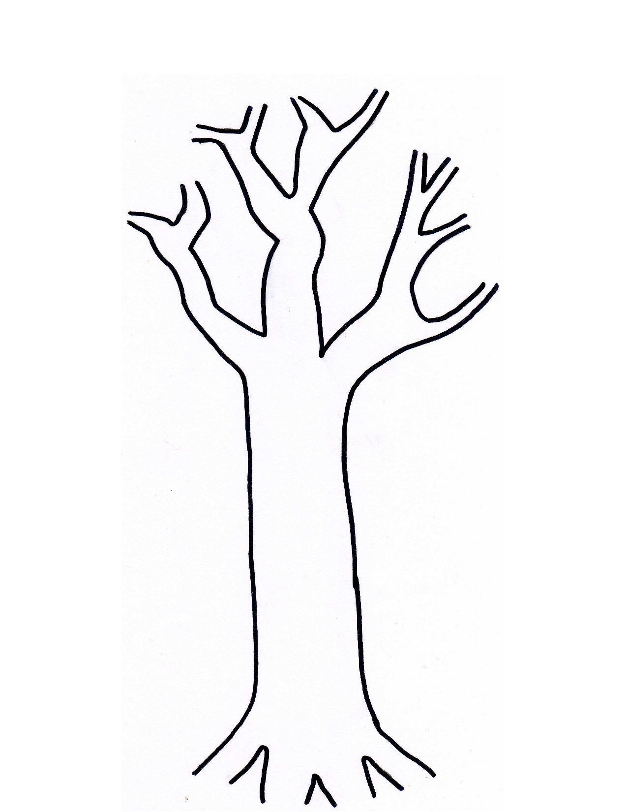

**Root Causes**

**(Motives)**

Name

Date

Colonized Point of View

Imperialist or Colonizer Point of View

**Western Imperialism**

**Rapid Spread of**

**of Imperialism**

**Forms**

1.

4.

3.

2.

Definition:

**WHAT IS IMPERIALISM?**