Finals Option 2 - Comic Book

Worth 100 points

OBJECTIVES: 1) STUDENTS WILL EXPLAIN AND PLACE IN ORDER THE MAJOR EVENTS OF THE COLD WAR 2) STUDENTS WILL KNOW THE CAUSES, EFFECTS, AND OUTCOMES OF THE MAJOR GLOBAL EVENTS DURING THE COLD WAR

Materials: Markers, Pens, Pencils, Books, Paper

Directions. You will work with a partner. You will design a comic book that demonstrates the major events of the Cold War.

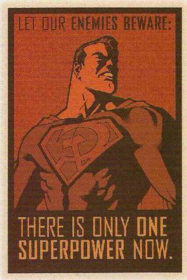
Comic Book will include:
1. Pictures that show the events that happened
2. Captions along with the picture that convey what historical event is occurring
3. Color (or good black and white drawings are OK)
4. The date of the Historical Event
5. Key Terms from each topic
6. Information that provides the comic book reader with an understanding of what happened

COLOR, HISTORICAL ACCURACY, AND GENERAL COOLNESS!!!

Your comic book will have at least ONE PAGE per EACH historical event:
- The Cold War Unfolds (502)
- Communism Spreads to China (521)
- The Korean War (524)
- Vietnam War (528)
- The Cuban Revolution and Cuban Missile Crisis (506)
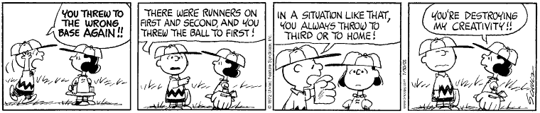

Terms You Must Use in the Comic
The Cold War Unfolds  Containment, Berlin Airlift, Truman Doctrine, Marshall Plan NATO, Warsaw Pact, Brinkmanship, Superpowers, ideology | Communism Spread to China  Mao Zedong, Jiang Jeishi (Chiang Kai Shek), Communes, Cultural Revolution, Great Leap Forward, Taiwan | The Korean War  MacArthur, 38th Parallel, United Nations, Pusan, Kim Il Sung, Syngman Rhee, DMZ | The Vietnam War  Domino Theory, Ho Chi Minh, Vietcong, Ngo Dinh Diem, Vietminh, Dienbienphu, Guerilla, Tet Offensive, Fall of Saigon | Cuban Rev/Cuban Missile Crisis  Bay of Pigs Invasions, Castro, Revolution, Soviet Missiles, Khrushchev, JFK, Naval blockade

Comic Book Grading Rubric
Criteria | 3 points | 5 points | 7 points | 10 points
Content  (30 points) | Student has done little research into the Cold War events. | Student has some evidence of research into the Cold War events. | Student has significantly researched into the Cold War events. | Student has thoroughly researched into the Cold War events.
Historical Accuracy of Pictures/  Drawings  (30 points) | Pictures/Drawings are not accurate historically, in terms of outlook and appearance. | Pictures/Drawings are somewhat accurate historically, in terms of outlook and appearance. | Pictures/Drawings are mostly accurate historically, in terms of outlook and appearance. | Pictures/Drawings portrayed are highly accurate historically, in terms of outlook and appearance.
Requirements  (10 points) | Less than 75% of the required content was present. | At least 75% of the required content was present. | Almost all the required content was present. | All of the required content was present.
Design and Syntax  (20 points) | Illustrations are limited in detail and little advance the telling of the story. Text lacks organization and is hard to read. | Illustrations are partially detailed and partially advance the telling of the story. Text is somewhat organized and readable. | Illustrations are detailed and somewhat advance the telling of the story. Text is well organized and easy to read. | Illustrations are highly detailed and significantly advance the telling of the story. Text is extremely well organized and easy to read.
Creativity  (10 points) | Comic book is limited in creativity and interest. | Comic book is somewhat creative and interesting to read. | Comic book is creative and interesting to read. | Comic book is highly creative and interesting to read.

