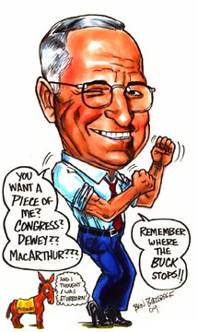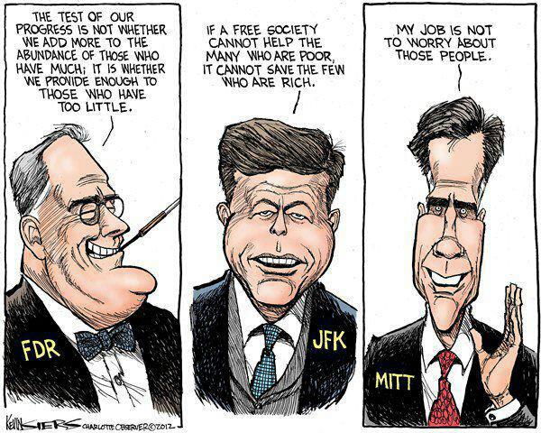14.5 End of World War II

Potsdam Conference

Yalta Conference

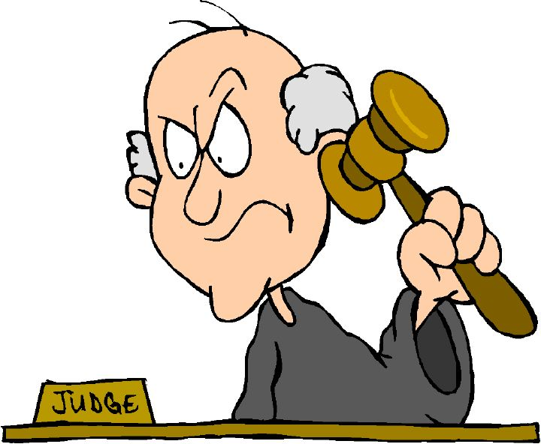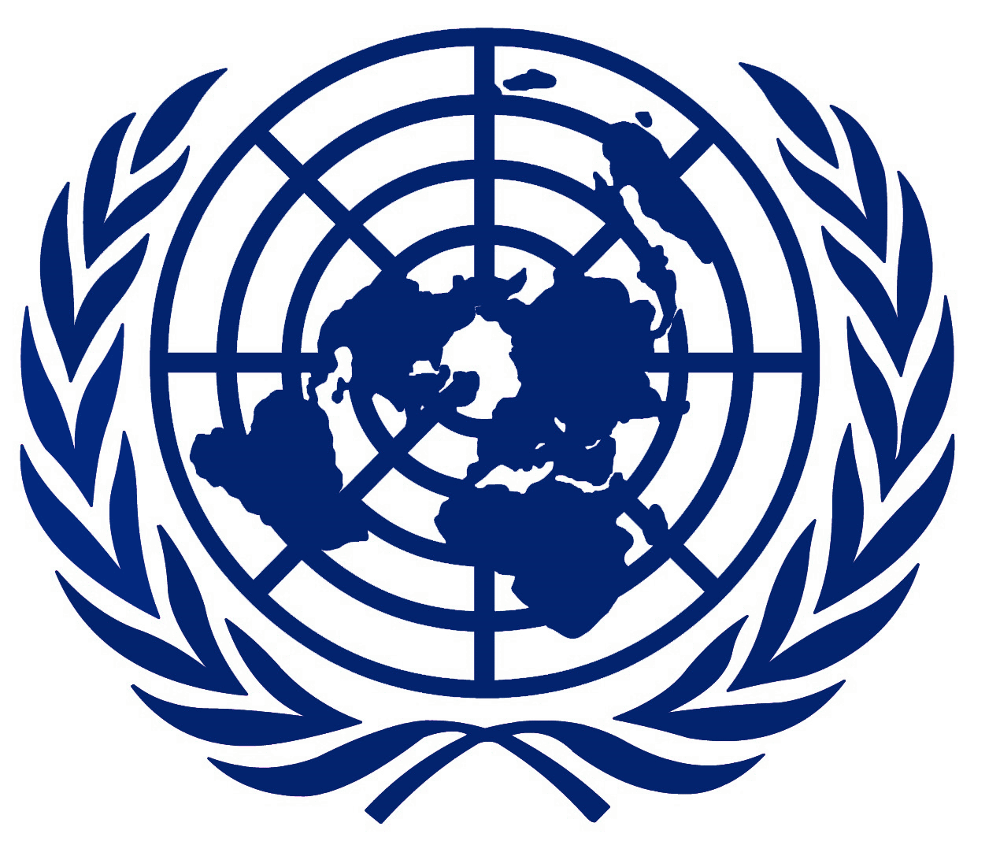

**Compare & contrast the United Nations and the League of Nations.**

Nuremberg Trials

What?

Who?

Where?

Why?

United Nations

Casualties

* Which nation in **Europe** suffered the greatest number of civilian and military casualties?
* Least?
* Which nation in **Asia** suffered the greatest number of civilian and military casualties?

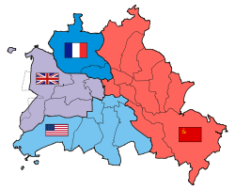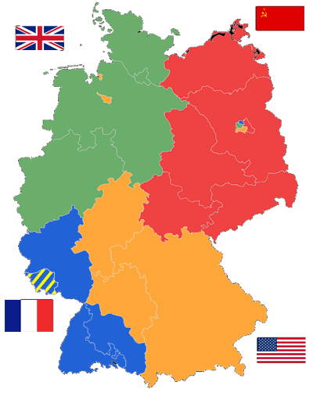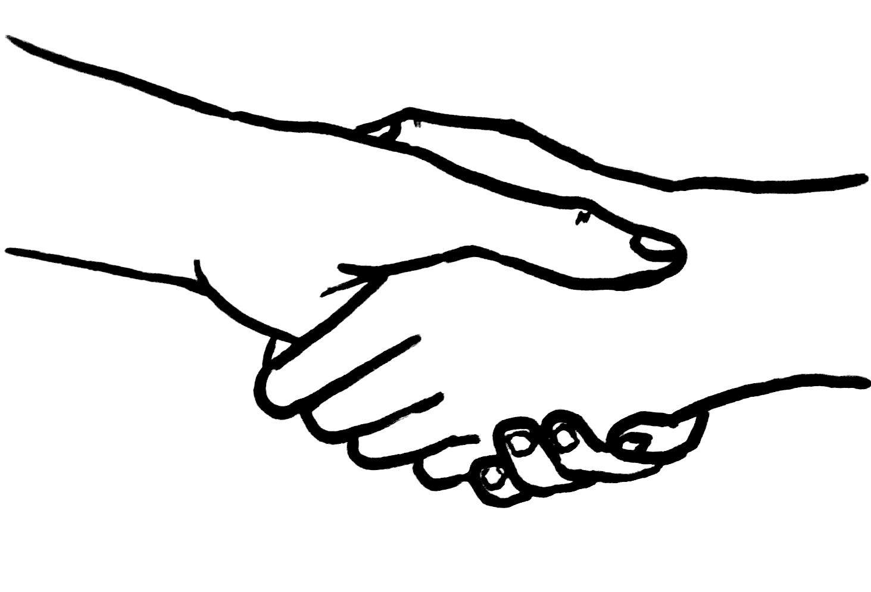

SUPERPOWERSSS

U.S.S.R. 

U.S.A. 

What happened to Germany and the city of Berlin after WWII?

Draw a RED line to indicate the Iron Curtain.

Germany

Berlin