Treaty of Versailles
Complete this table to categorize issues and problems that resulted from agreements made after the war.
Issues | Treaty Settlement | Problems
War Debt | Because of the treaty, the new German Republic had to make large payments to pay for the damage caused by the war. | These payments would hurt an already damaged German economy.
Fear of German Strength | The treaty limited the size of the German military. | Germans resented the treaty demands.
Nationalism | The treaty created new states. | Some ethnic groups became unwanted minorities in the new states.
Colonies and Other Non-European Territories | The treaty created a system of mandates. (territories administered by Western powers) | Mandates added to imperial rule instead of ending it.
League of Nations | The treaty established the League of Nations. | The U.S. did not join, thereby weakening the League’s power.
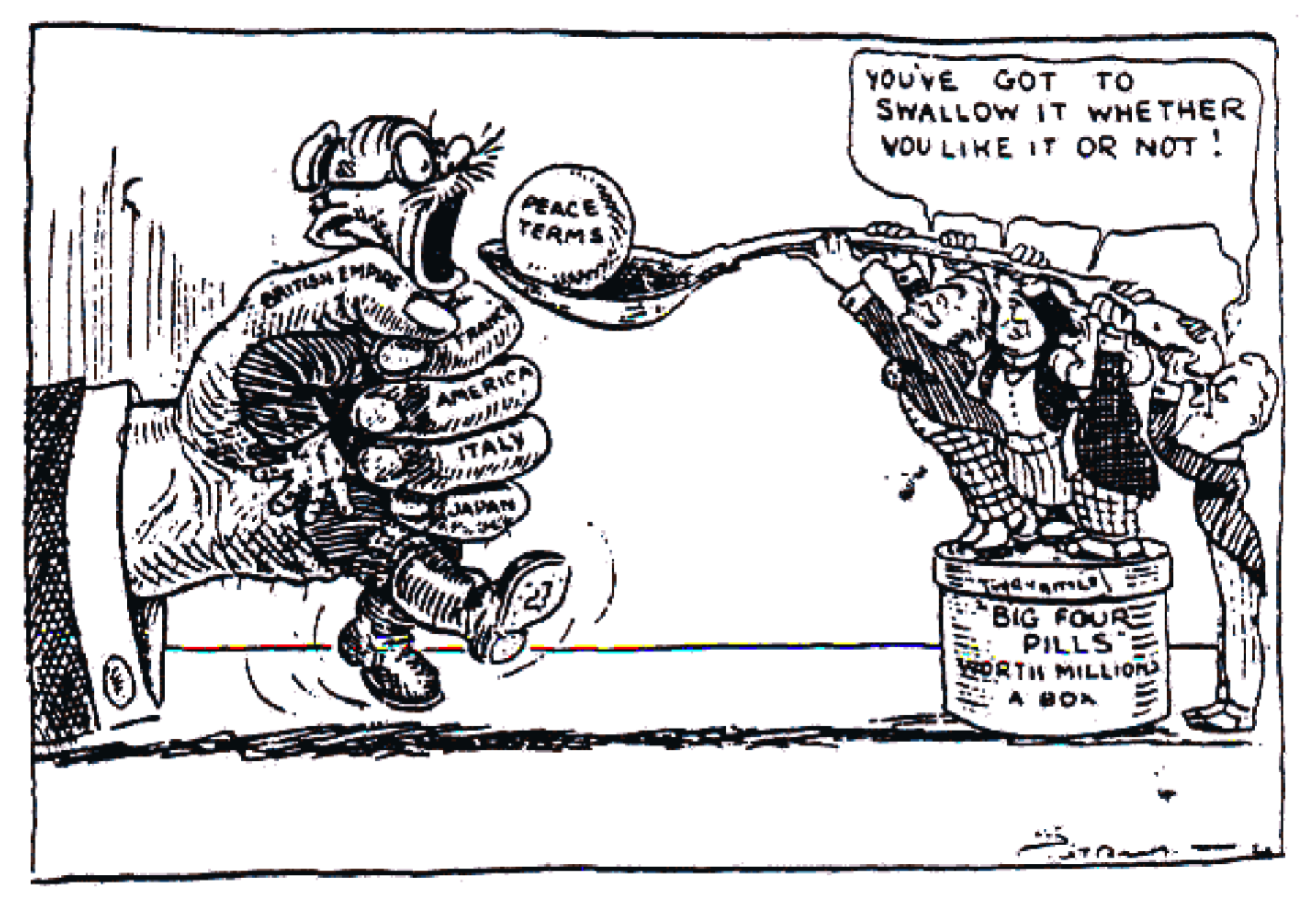
On the back, write a short story describing what is occurring in the political cartoon.

